Lighthouse report before-contact: Lighthouse report after-contact: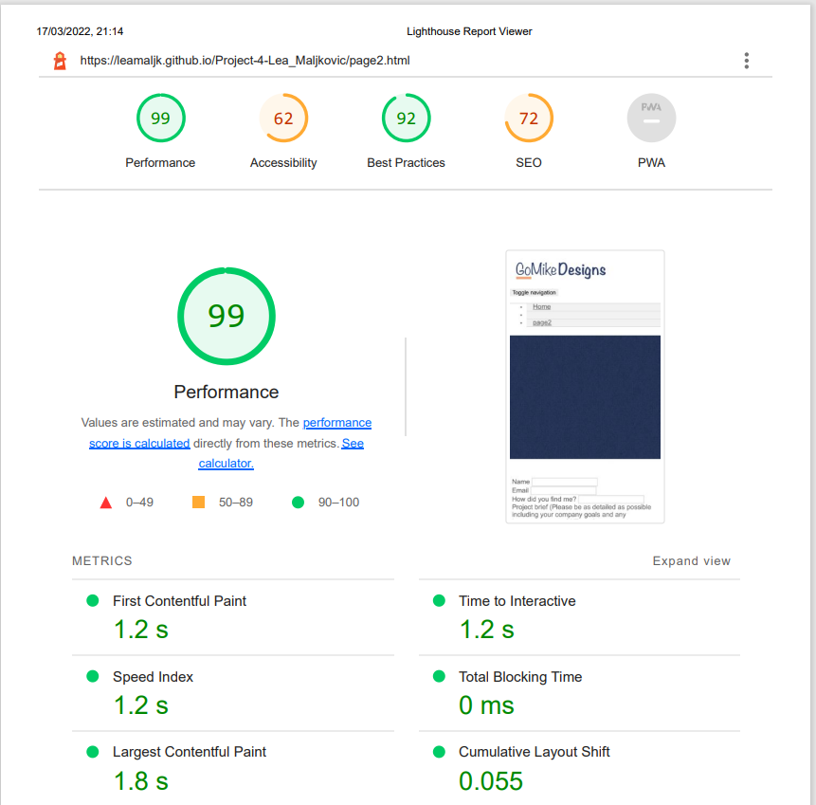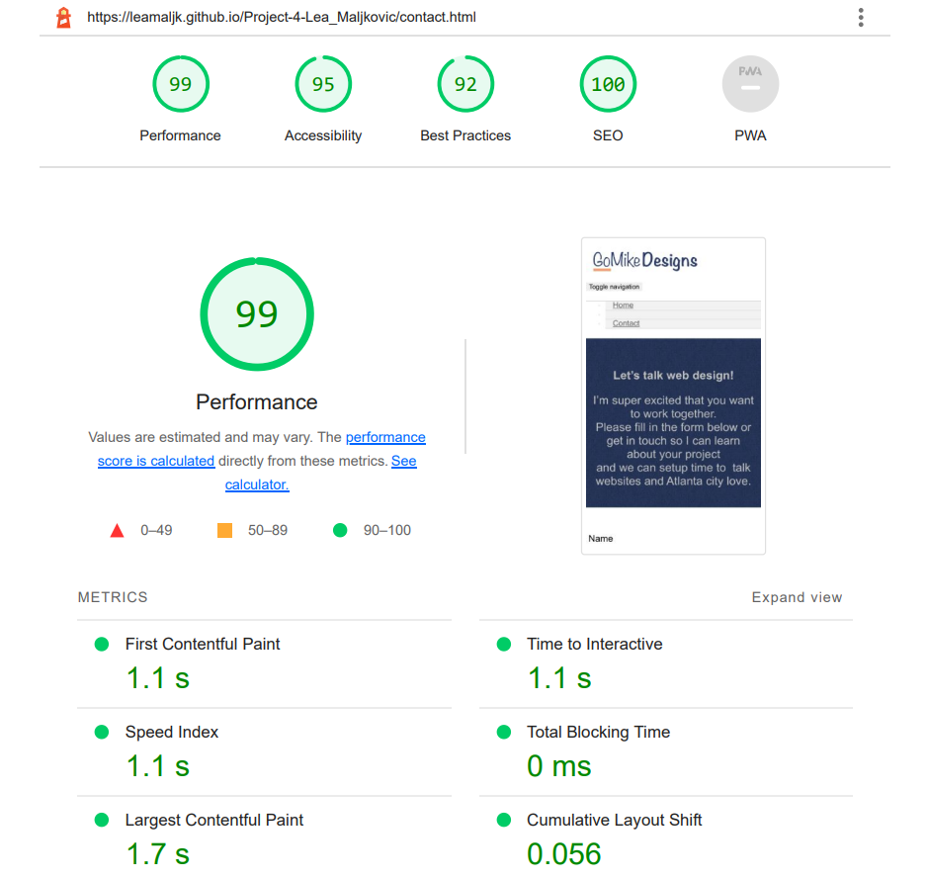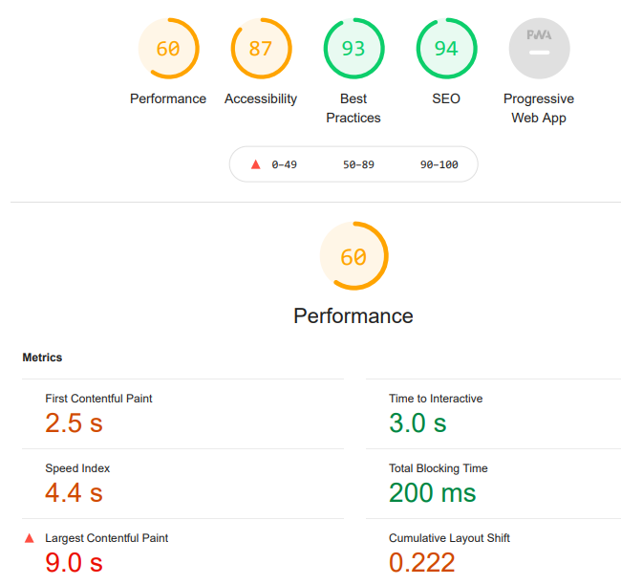

Lighthouse report before-Home: Lighthouse report after-Home: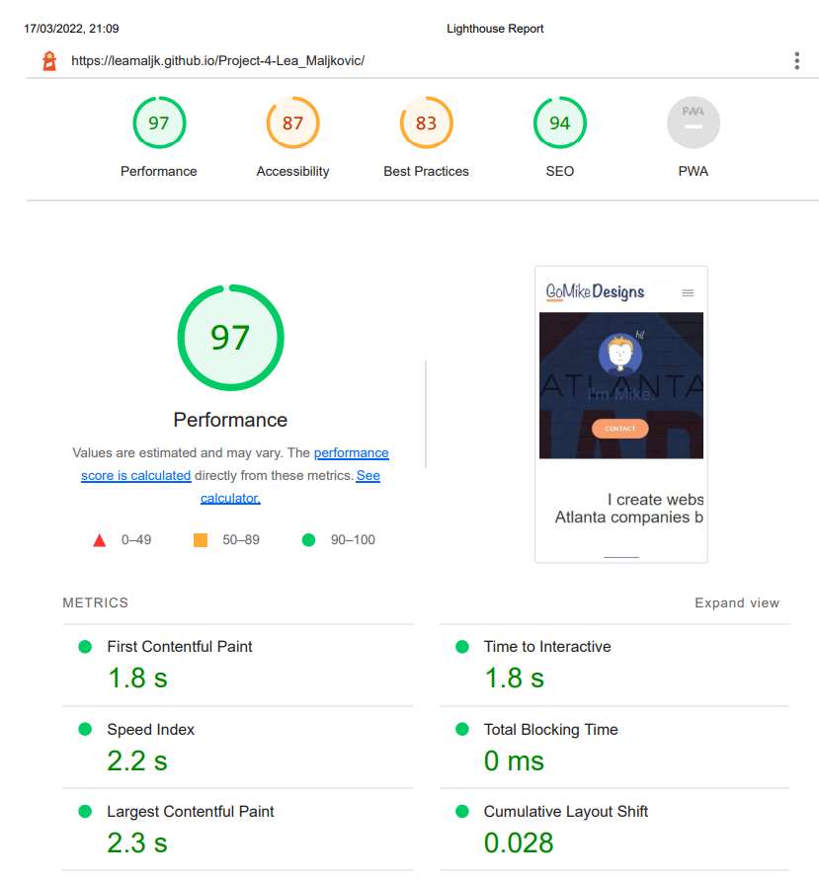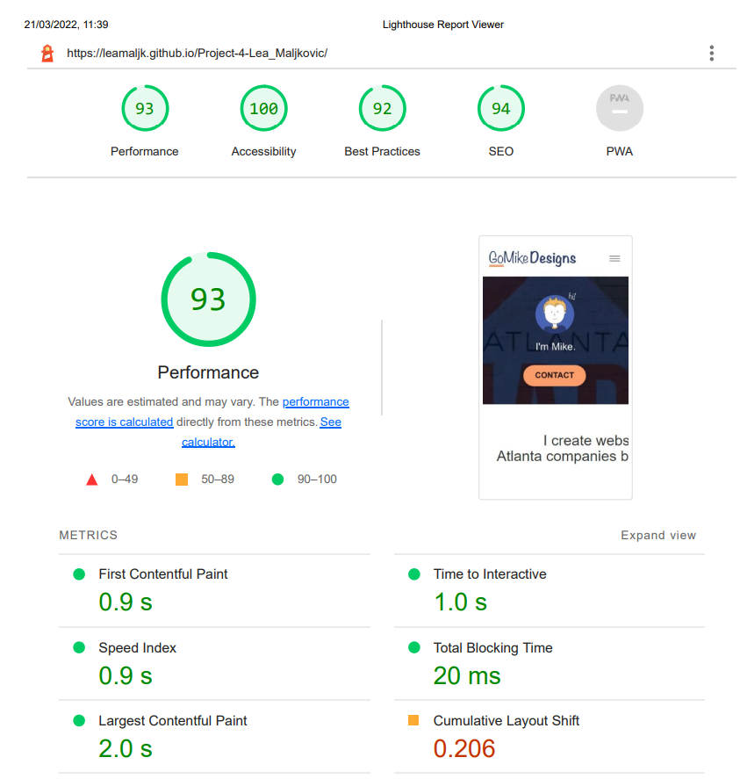

Reccomandations:

1. Image elements do not have explicit width and height,assigning a width and height sttribute to images in HTML will avoid making the browser move the text to make space for the pictures, it will reserve the space from the attributes directly.
2. Low-contrast text is difficult or impossible for many users to read. Always make sure background and foreground colors have a sufficient contrast ratio.
3. Serve images in next-gen formats.Image formats like WebP and AVIF often provide better compression than PNG or JPEG, which means faster downloads and less data consumption.
4. Make sure that heading elements are in a sequentially-descending order, to help screen readers navigate the website.
5. Always add a lang attribute with a correct value to help screen readers use the correct pronunciation.
6. Pictures of text are difficult for screen readers to recognise and render, so they should never be used unless it’s necessary.
7. Add a title. The title gives screen reader users an overview of the page, and search engine users rely on it heavily to determine if a page is relevant to their search.
8. Links do not have a descriptive text or the text is inadequate.
9. Alt attributes help both screen readers or users who's browser can't render the pictures for tecnical reasons.
10. Interactive elements like buttons and links should be large enough, and have enough space around them, to be easy enough to tap without overlapping onto other elements.
11. Meta descriptions may be included in search results to concisely summarize page content.
12. Black hat SEO tecniques are ineffective on modern search engines and the pose a banning risk.